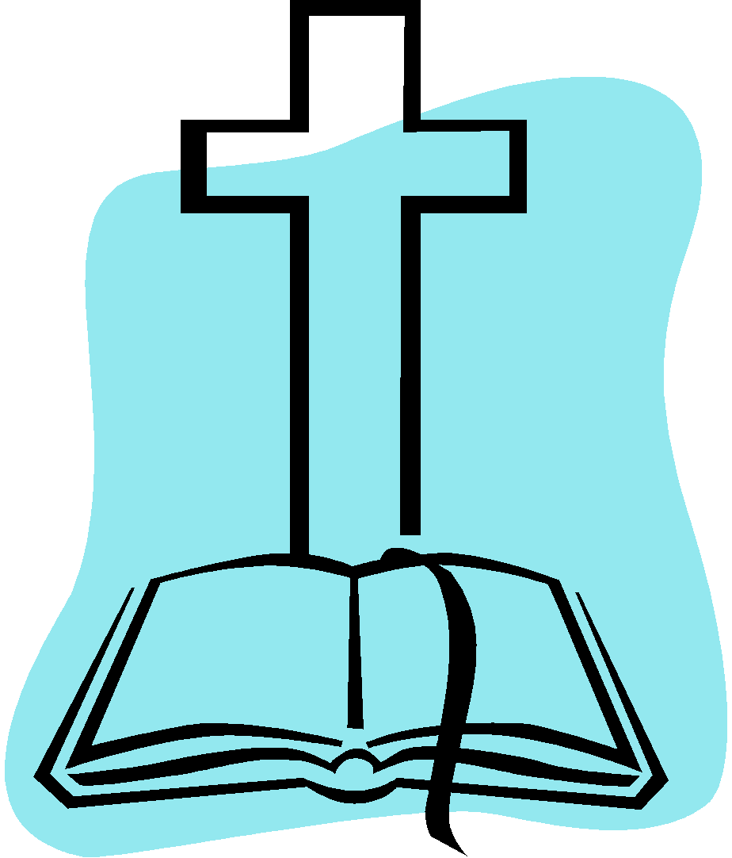
Spiritual Development Policy 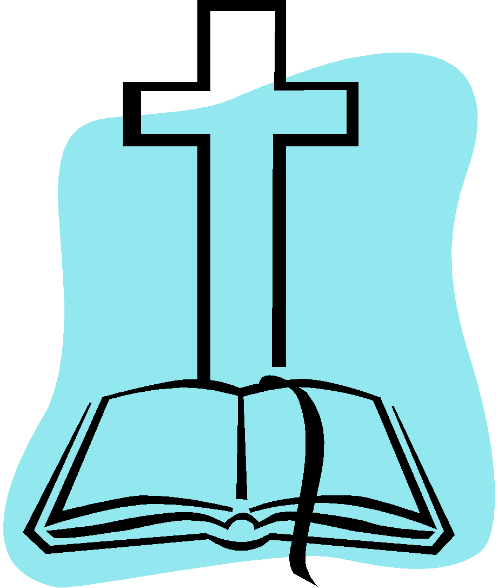

The Lion & Lamb Christian School, a ministry of Grace Church of Reno, has very specific objectives in its Christian education for your child. We are unashamedly Christian in all we do and teach. We base our Christian beliefs on the following:
1. The Bible is the Word of God.
2. This God is the creator of all things, seen and unseen.
3. Every human being has been created in the image of God which makes them a very special
person in God’s eyes.

4. There is only one God who eternally exists in three persons, i.e. the Father, Son and Holy Spirit
(The Trinity).

5. God, because of His great love, sent His Son, Jesus Christ, to die on the cross for the penalty of our
sins.

6. We are forgiven from our sins only by a personal faith in the Lord Jesus Christ.

We provide the following materials and activities as part of our Christian teaching:

- Age appropriate bibles in each classroom
- Bible games and puzzles
- Christian songs and music in each classroom
- Prayer will be said before snacks and lunch
- Bible stories will be read to the children
- Love and forgiveness will be emphasized

My signature here represents my understanding, acceptance and agreement with the above stated policy:

___________________________________________________________ _________________________________________________
Parent or Guardian Signature Date

___________________________________________________________ _________________________________________________
Parent or Guardian Signature Date

